1. **Type** Line developer for accessing into Line Developer

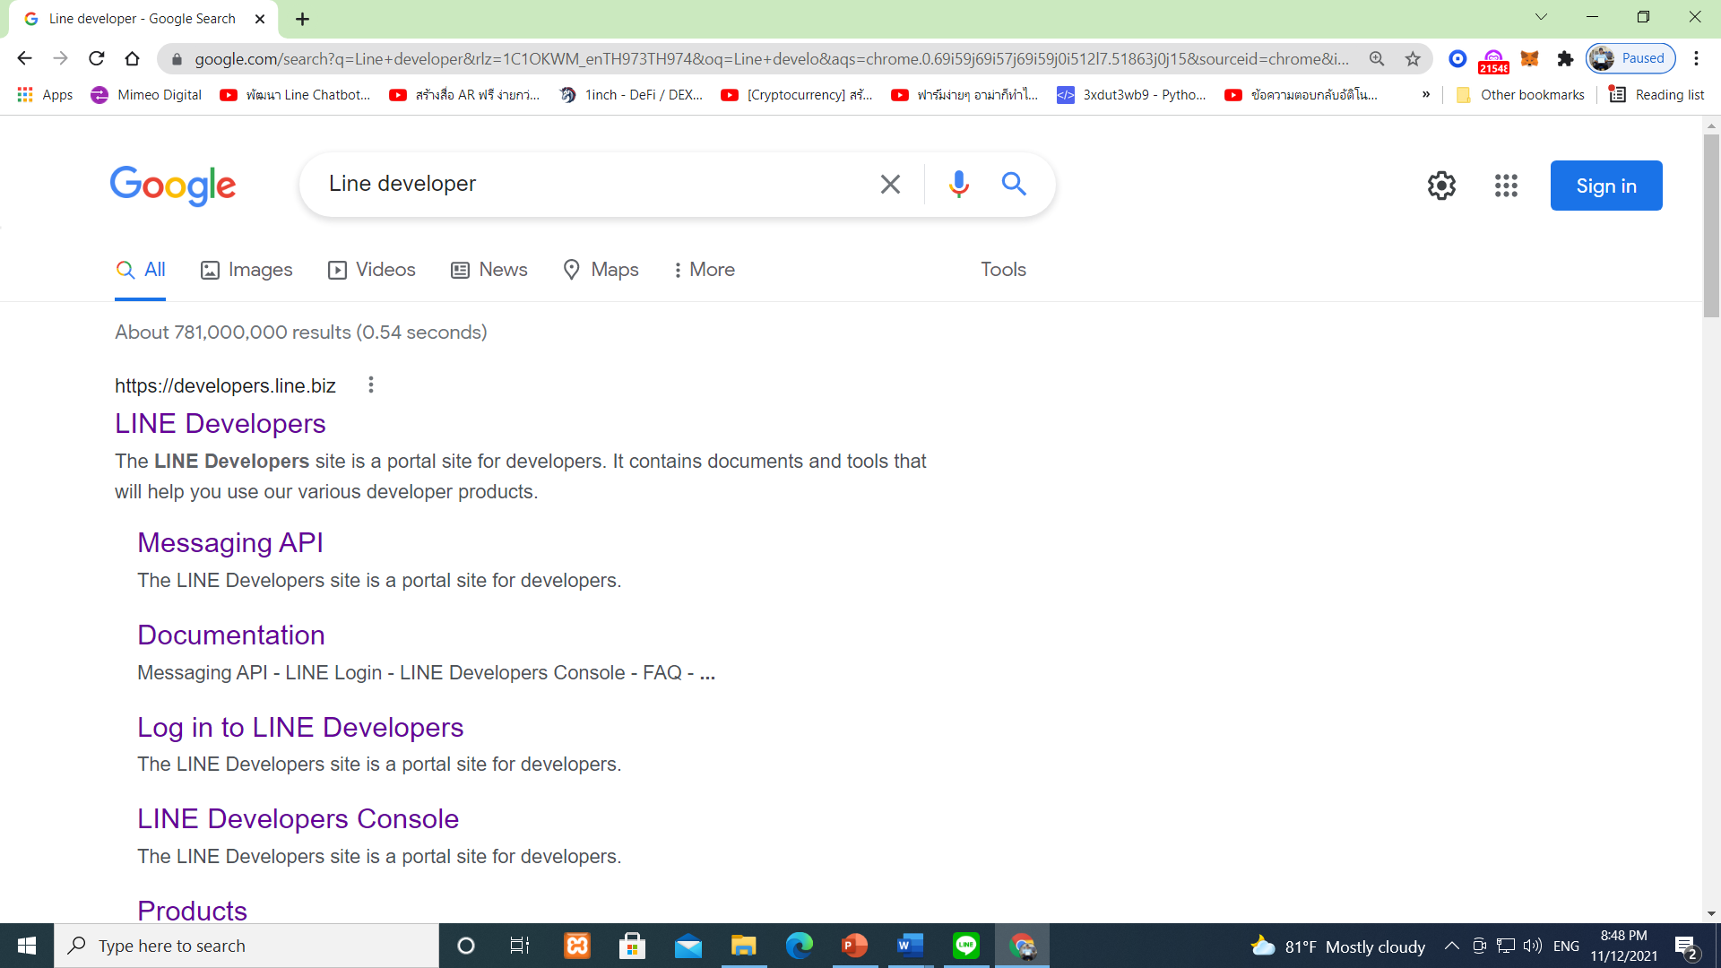

1. Click Log in

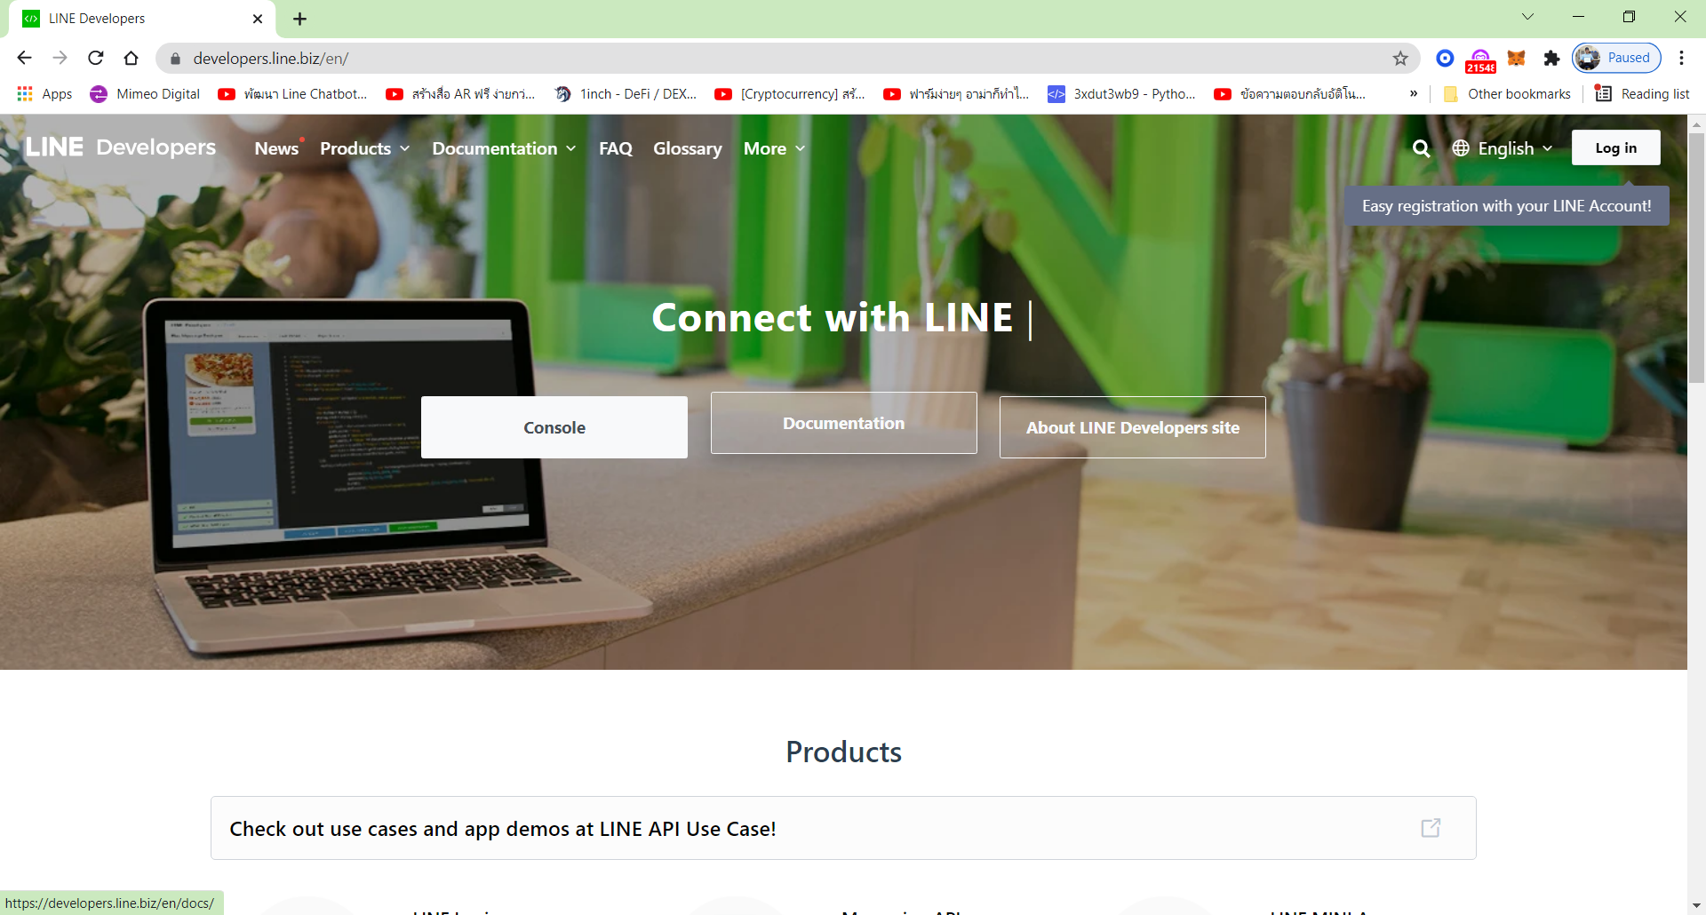

1. Open this Webpage for go to Log in with **Line Application**

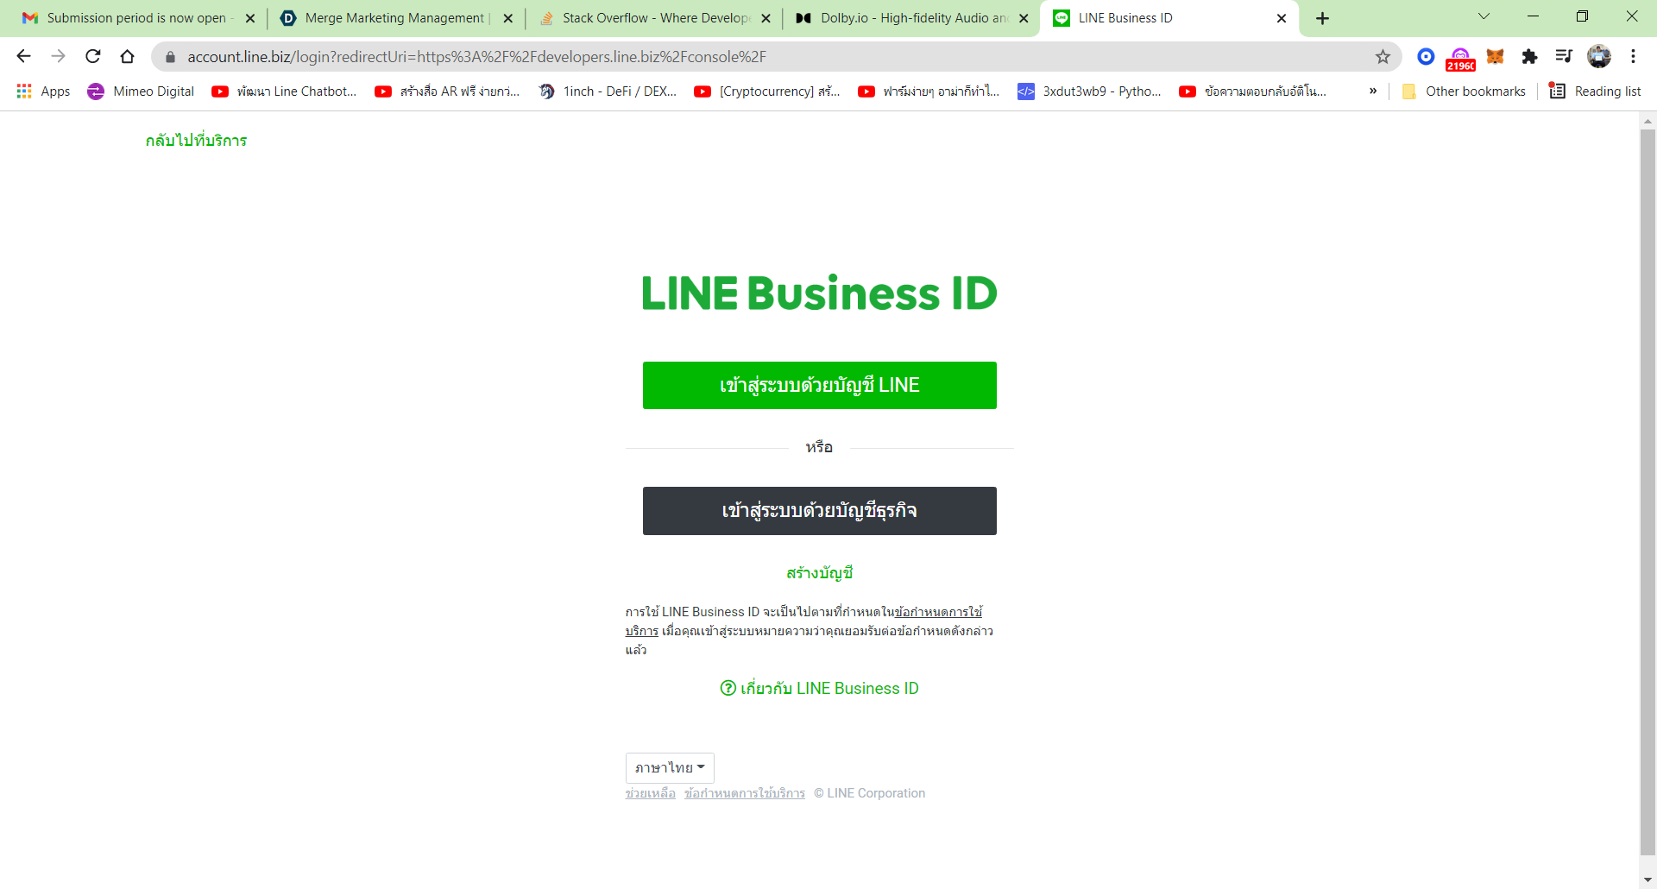

Click

1. This Webpage in Your Line Application

* **Click** Log in

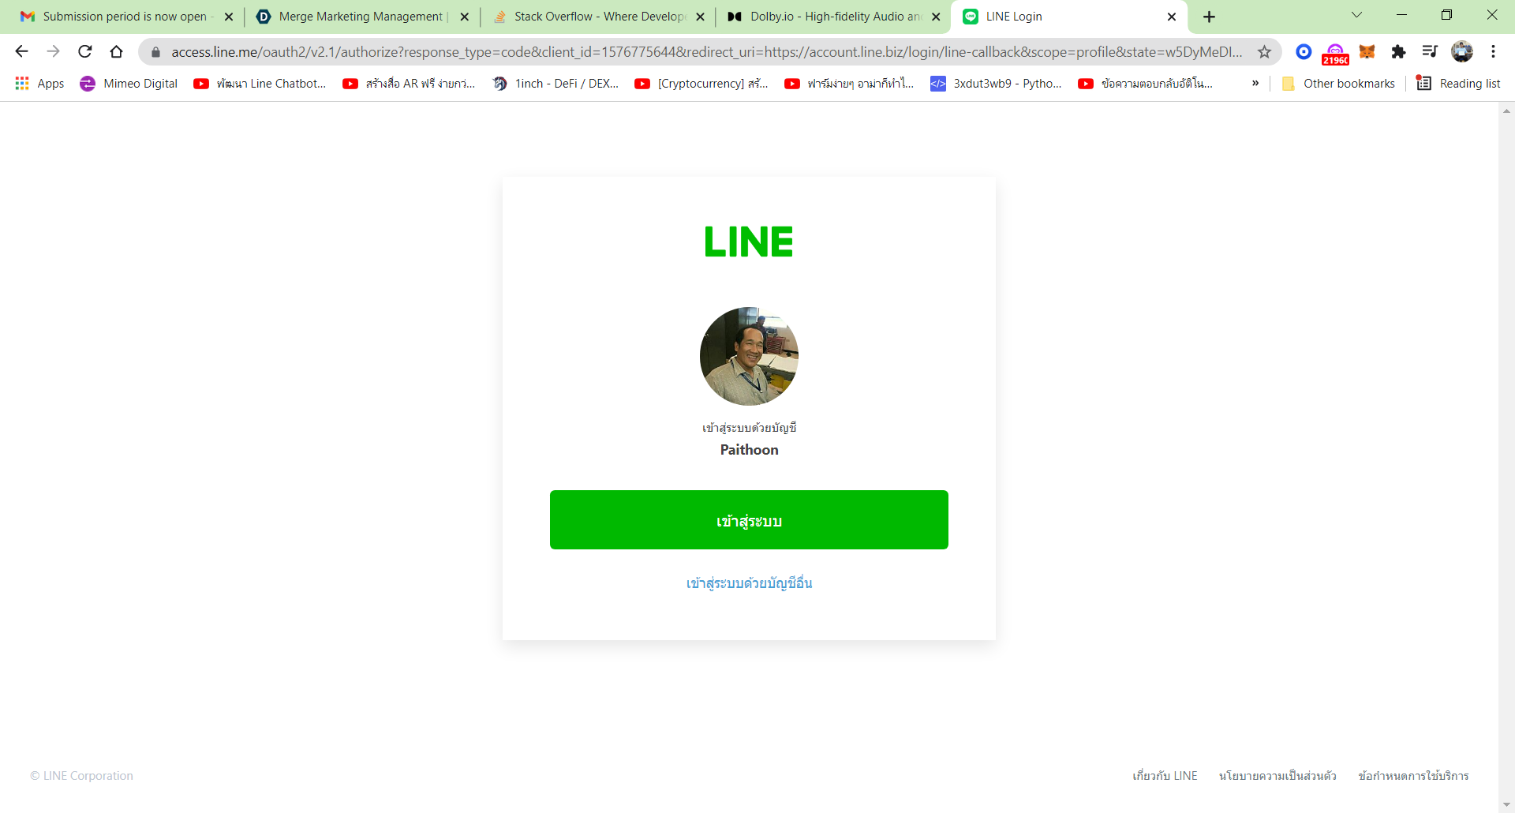

Click

1. This first webpage Line Developers

* Click Create at Product in Provides

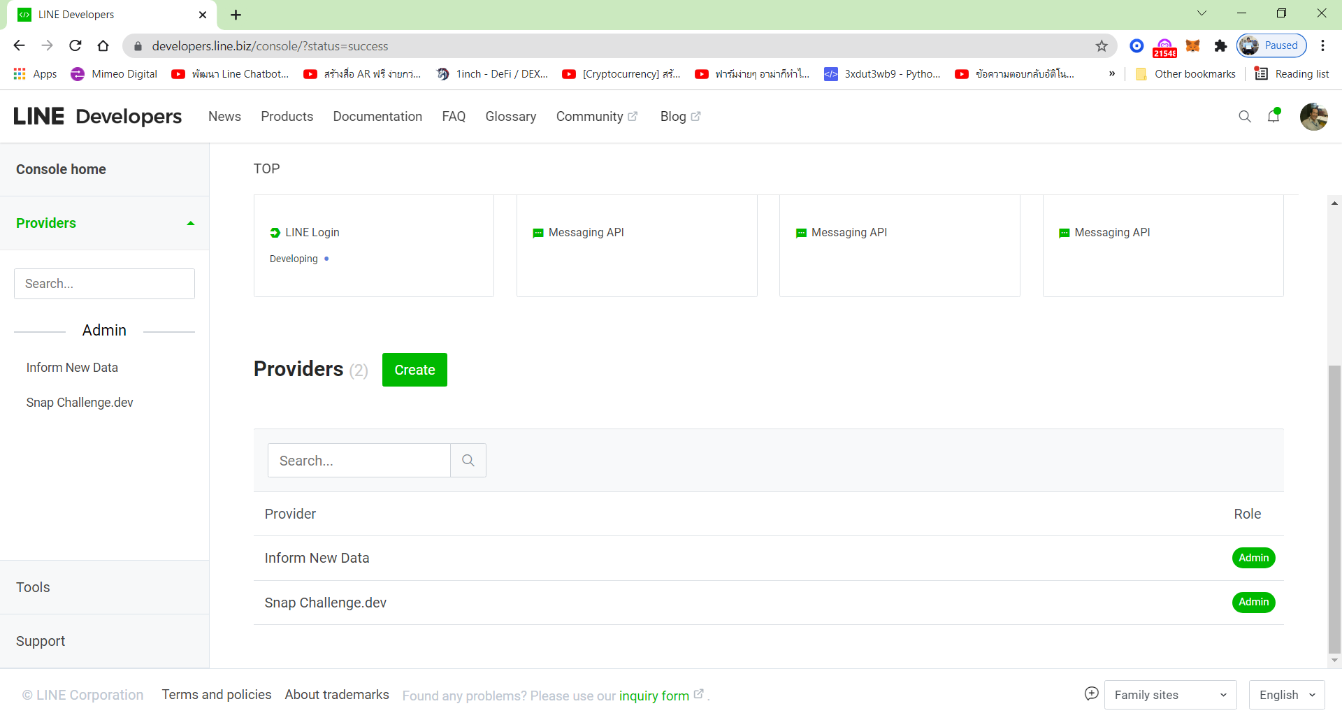

1

Click

1. This Webpage For setting in LIFF: Line Frontend Framework

* Type Name for LIFF occur in new Title



Click

1. **Name** occur in this webpage and Notification to setting **success**

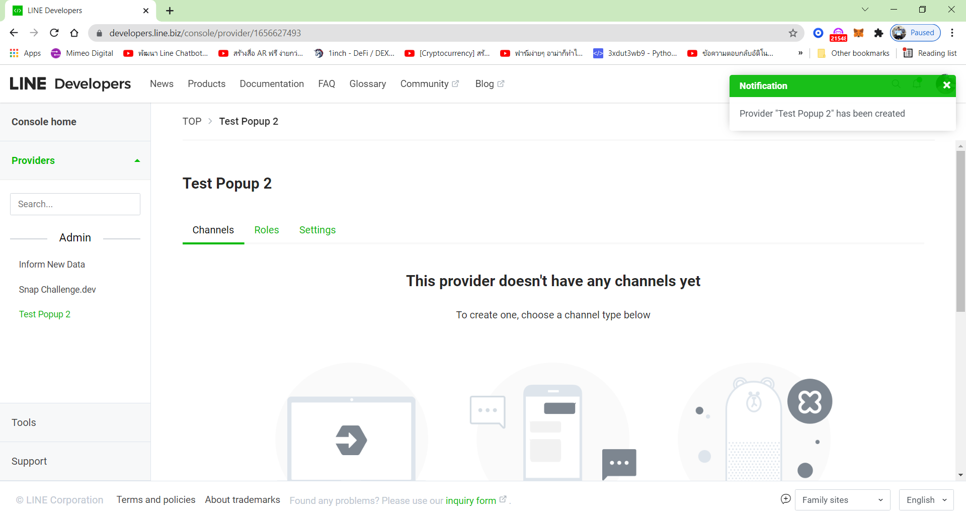

**Success**

Name

1. Setting Create a Channel

* Automatically Name is Messaging API
* You can change in any by type or click Dropdown
* Upload your picture (Any)

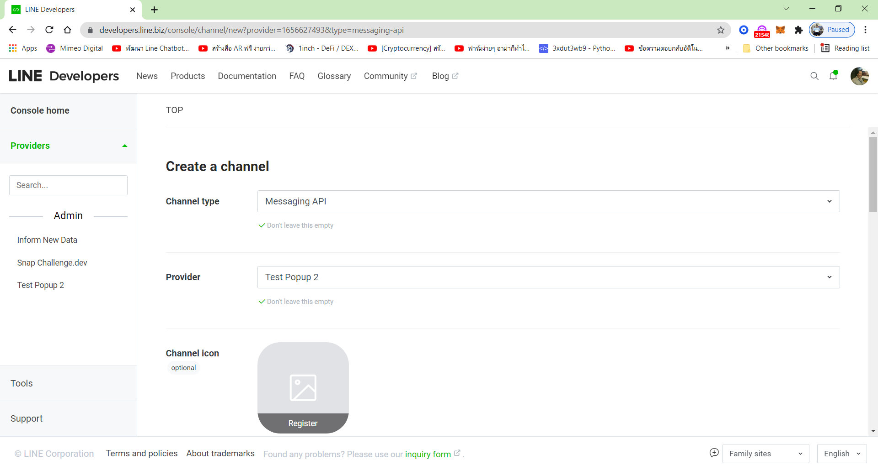

1. **Any Name**

**2. Any Name**

3. Click Up Upload Any Picture

1. Next to same webpage 8 scroll down fill it up without mark X

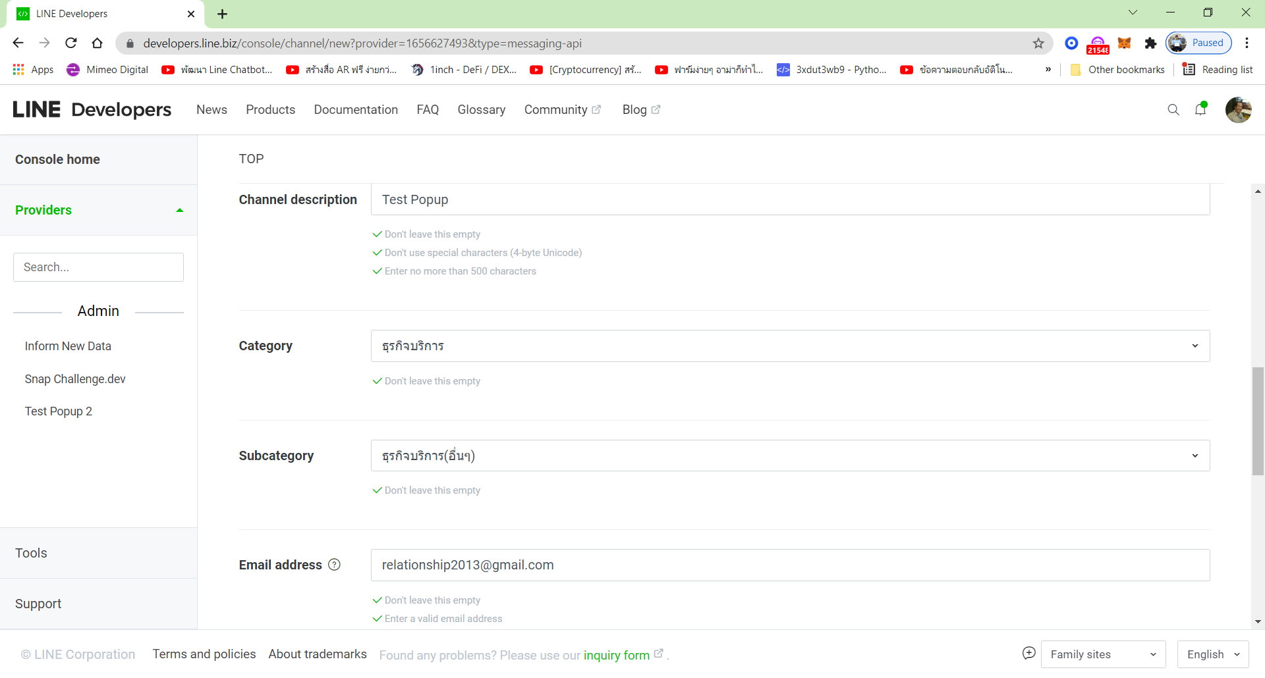

**3. Auto or new Email**

**2. Click dropdown selecting  
Click Dropdown**

1. **Any Name**
2. Next to same webpage 8 Mark 2 location

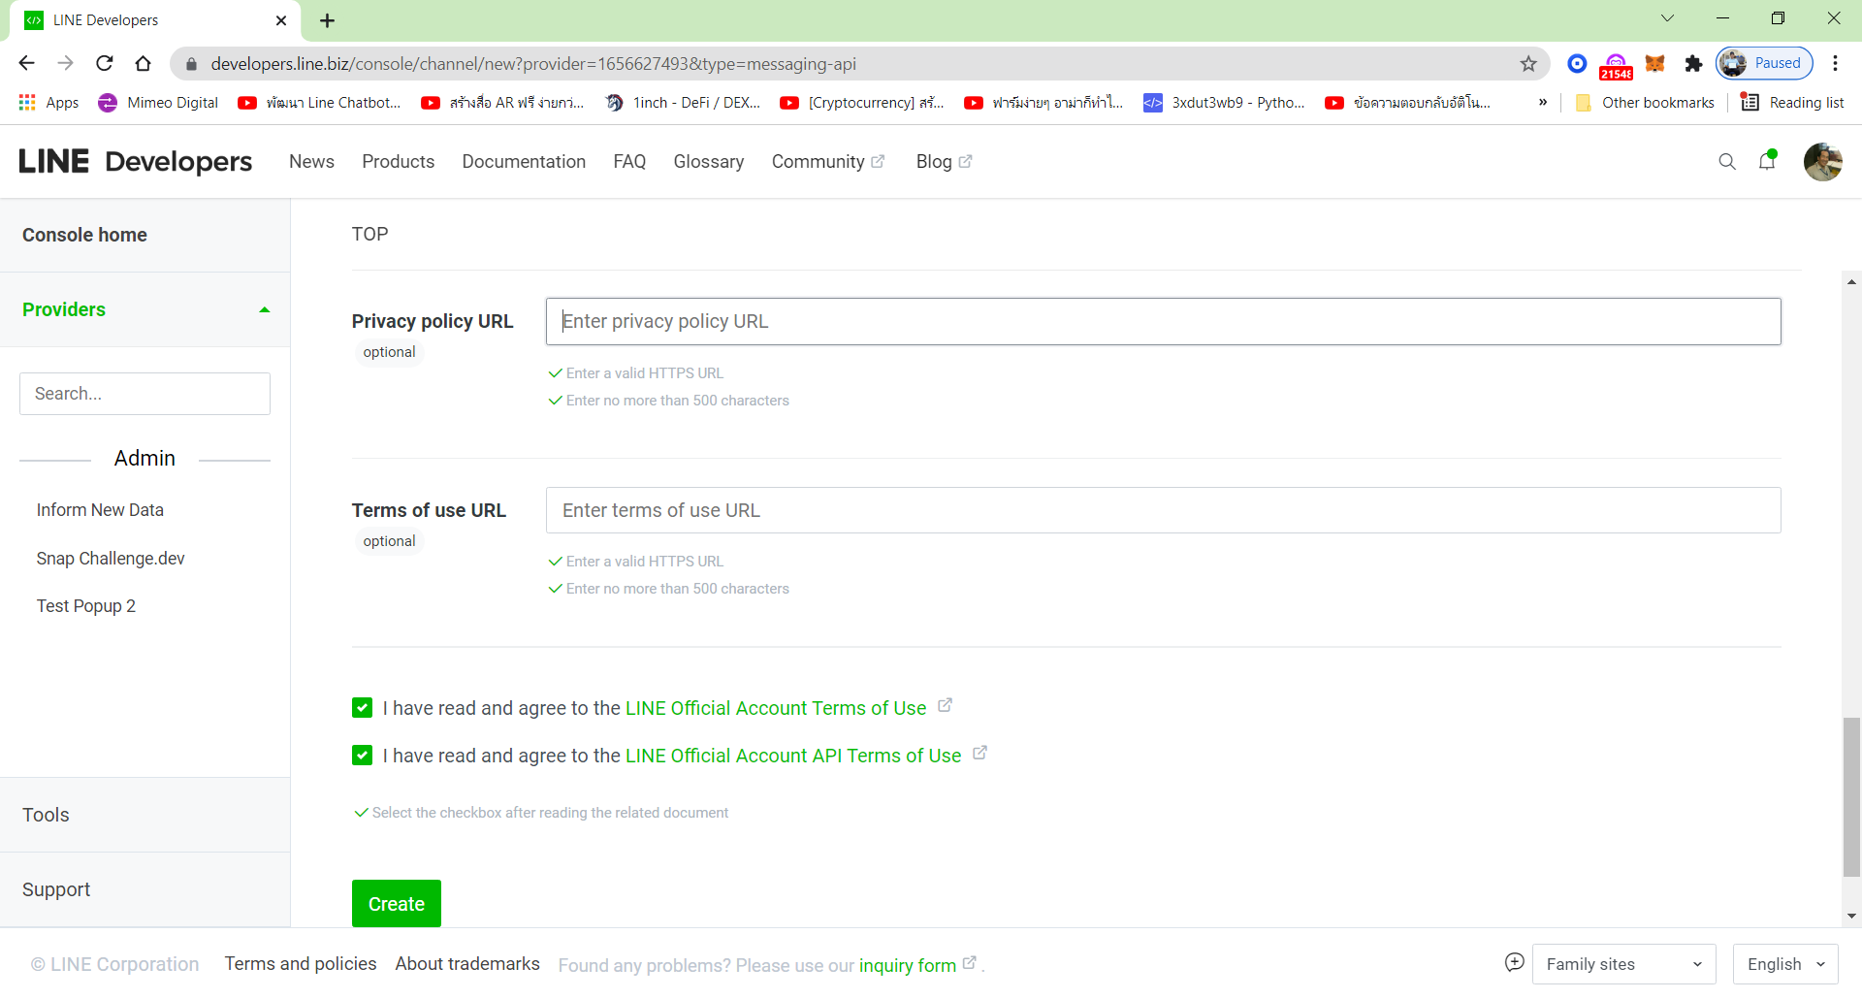

1. Mark 2 Choices
2. **Click Create**
3. Dialog box to Popup

* Click OK

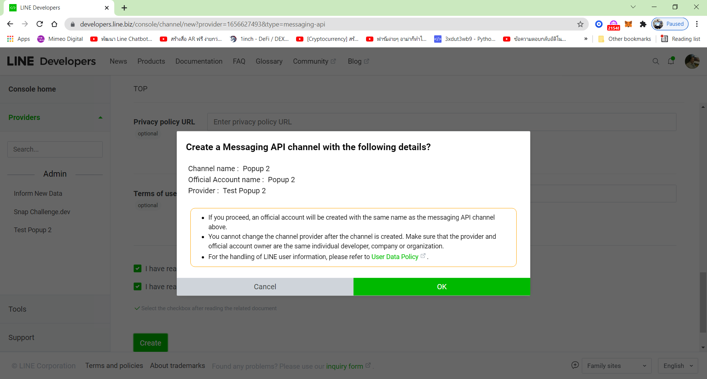

1. **Click OK**
2. Next to Popup

* **Click** Accept

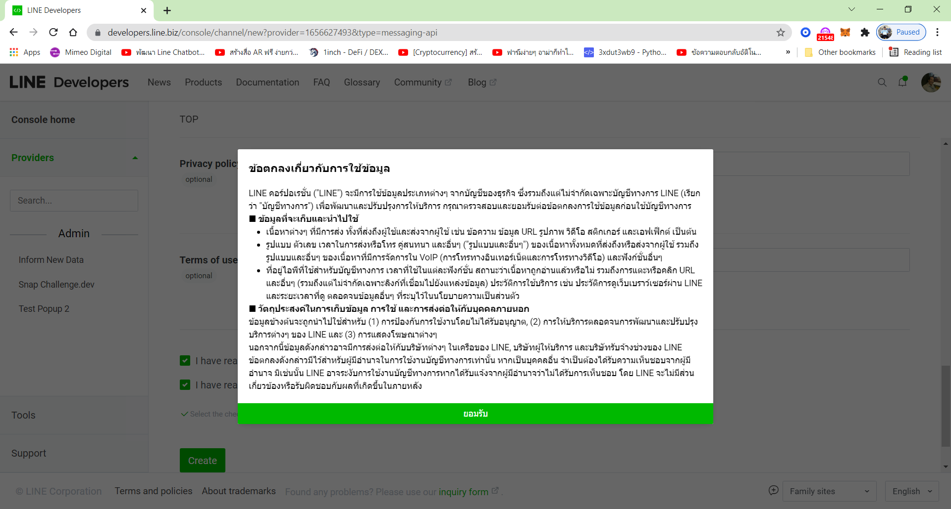

1. **Click Accept**
2. This Webpage occurs LIFF set it to finish

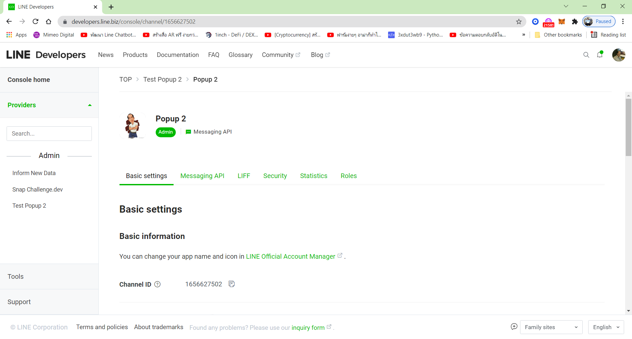

1. **Occur in LIFF**

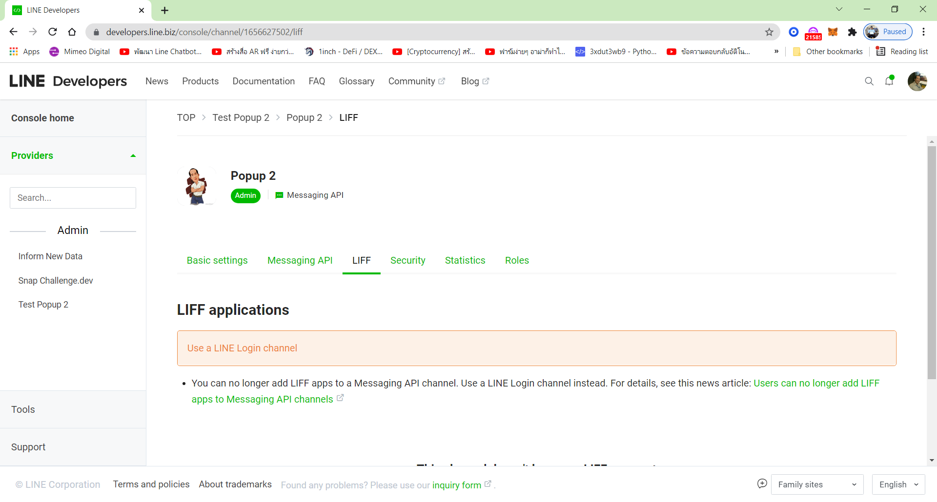

1. **Click Create**
2. **Click LIFF**
3. This webpage occurs

* **Click** Product
* **Click** Start now

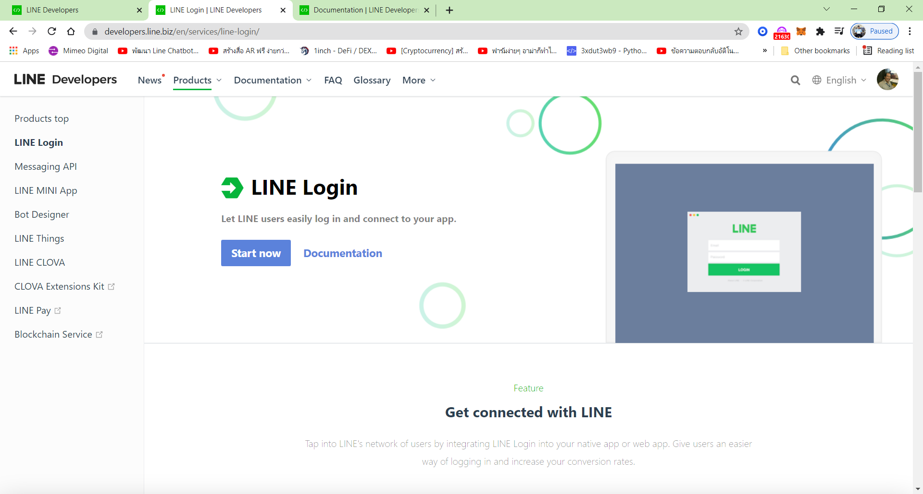

**1.Click Products**

**2.Click Start now**

1. This webpage occurs, fill it up as same LIFF Data

* **Channel type**: Type or click dropdown box to select name
* **Provider**: Click dropdown box to select type of setup in LIFF
* Region: Thailand or your Region

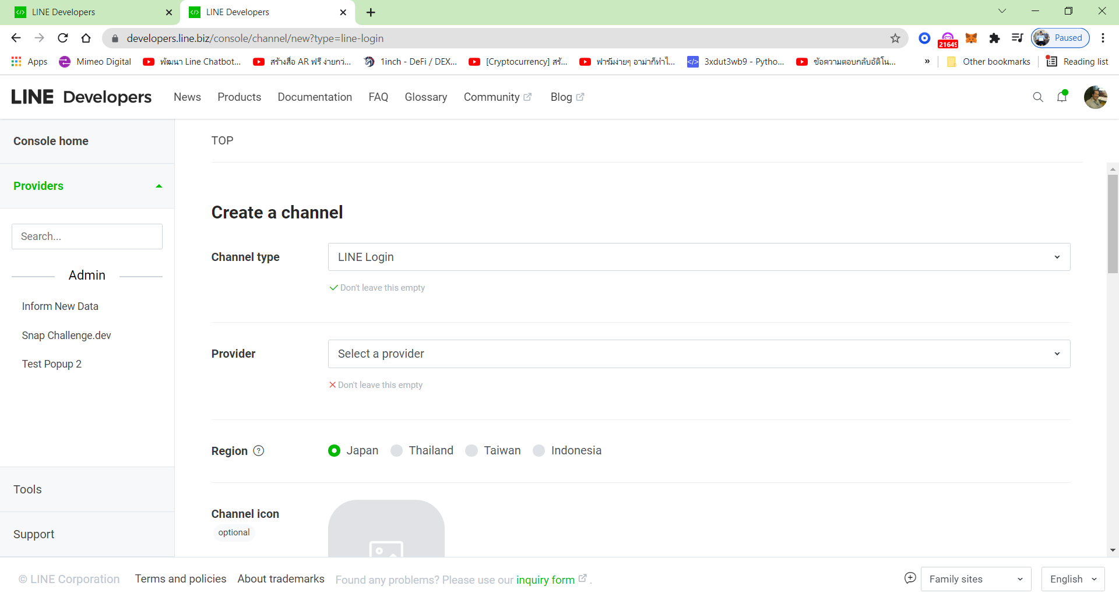

**2.Click dropdown**

**1.Click Dropdown**

1. This webpage as same page 15

* Upload Picture

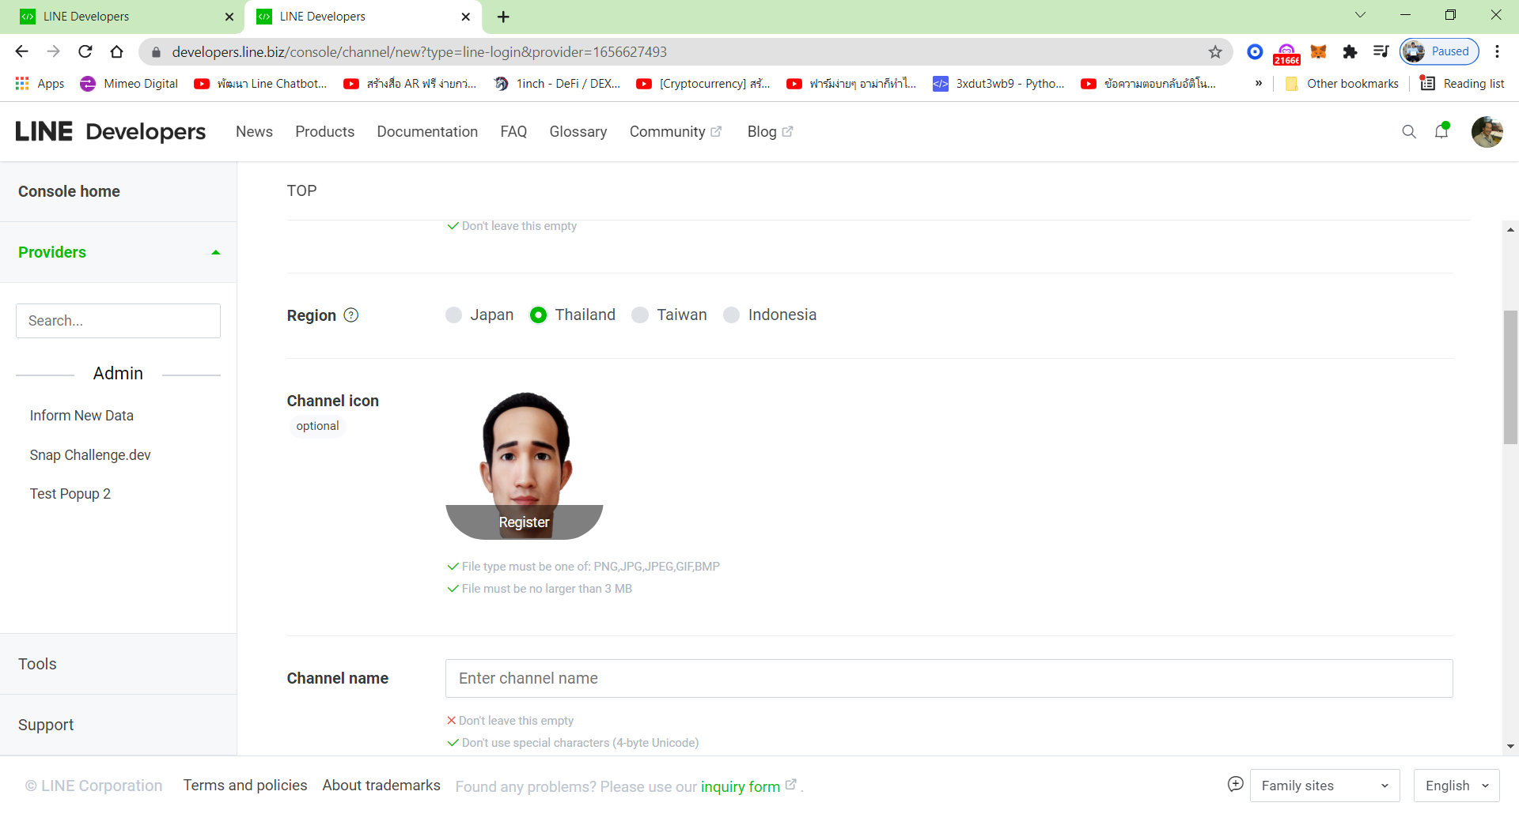

**1.Uplopad Picture**

1. This page as same page 15

* **Type** your description
* **Mark** in 2 choices
* **Type** Auto email address or new Email address

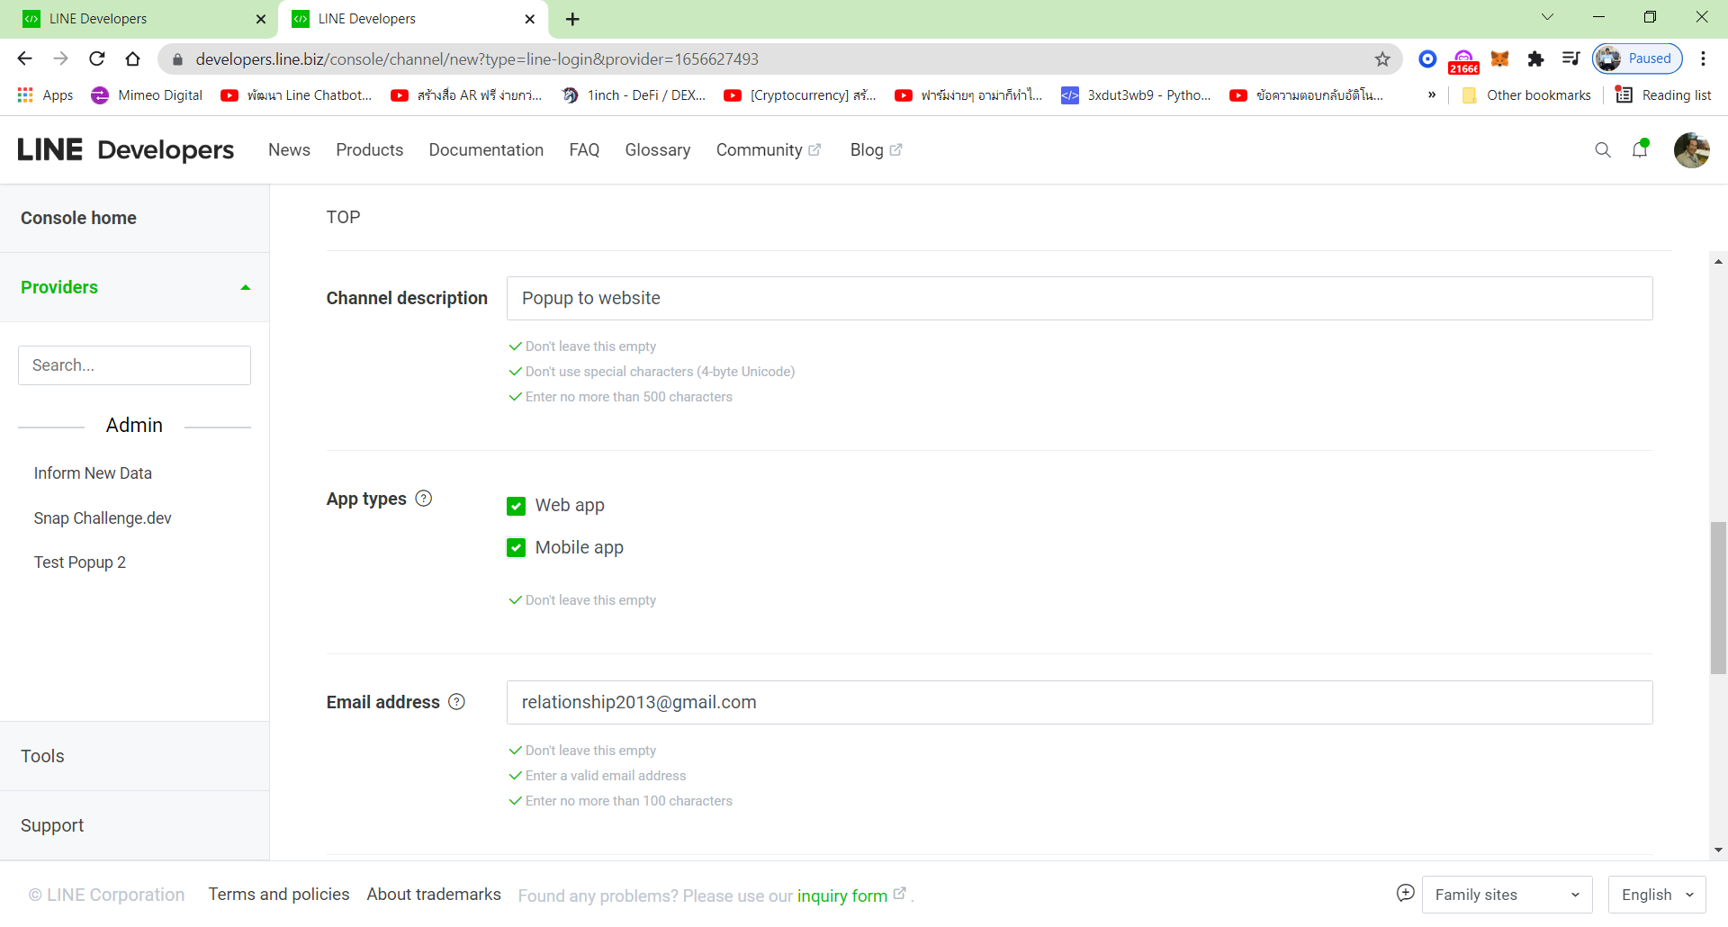

**2.Type your Email in Manual or Auto**

**2.Type your Description**

1. Mark 2 Choices
2. This webpage as same page 15

* **Mark** 1 Choices
* **Click** Create

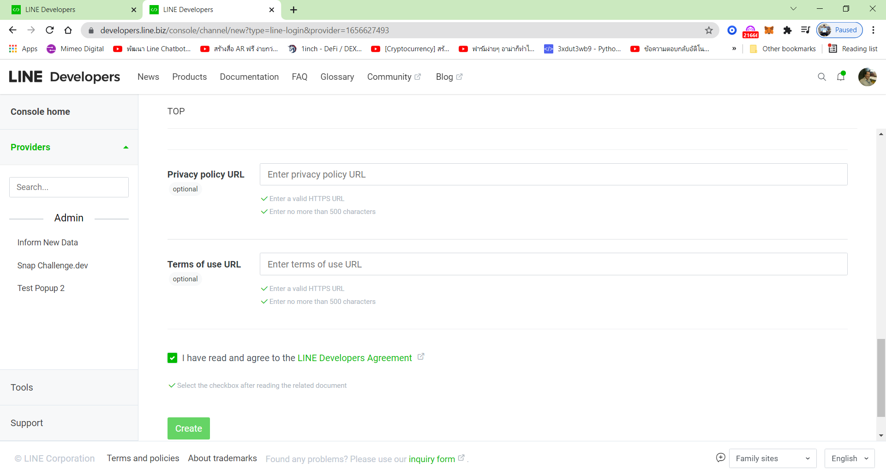

1.Mark 1 choices

2.Click Create

1. Popup occurs in **Notification,** and then fading.

* Click LIFF

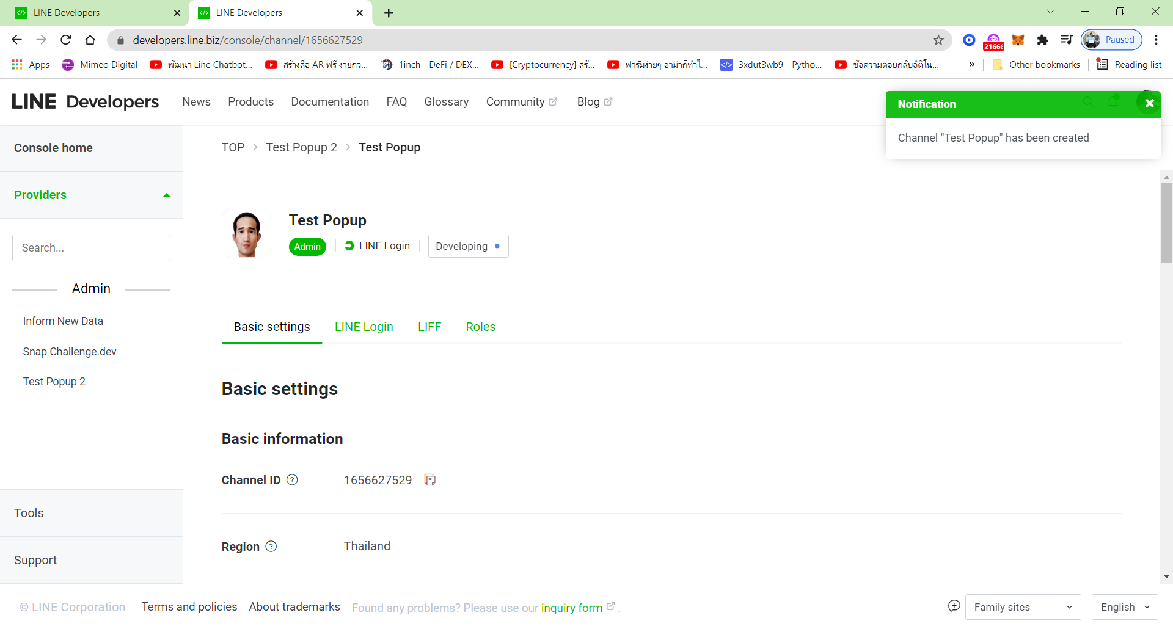

**2.Click LIFF**

**1.Occur in Notification**

1. Scroll down to see ADD

* **Click** ADD

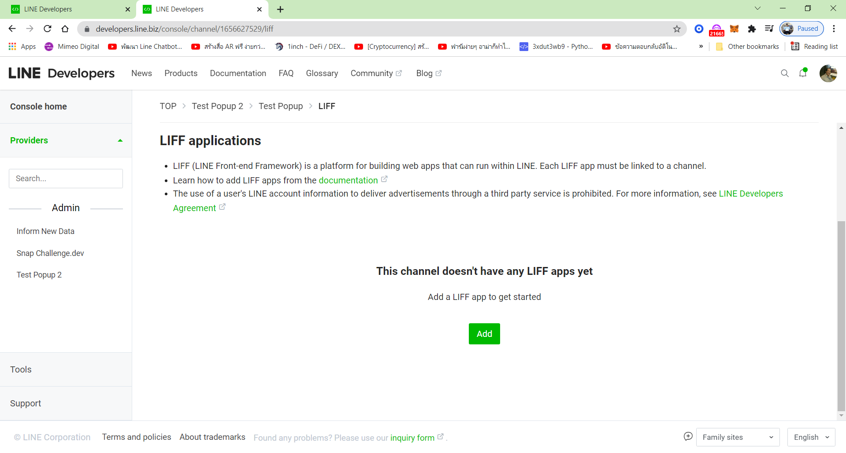

**2.Click ADD**

1. This webpage Add a LIFF to success

* Scroll down

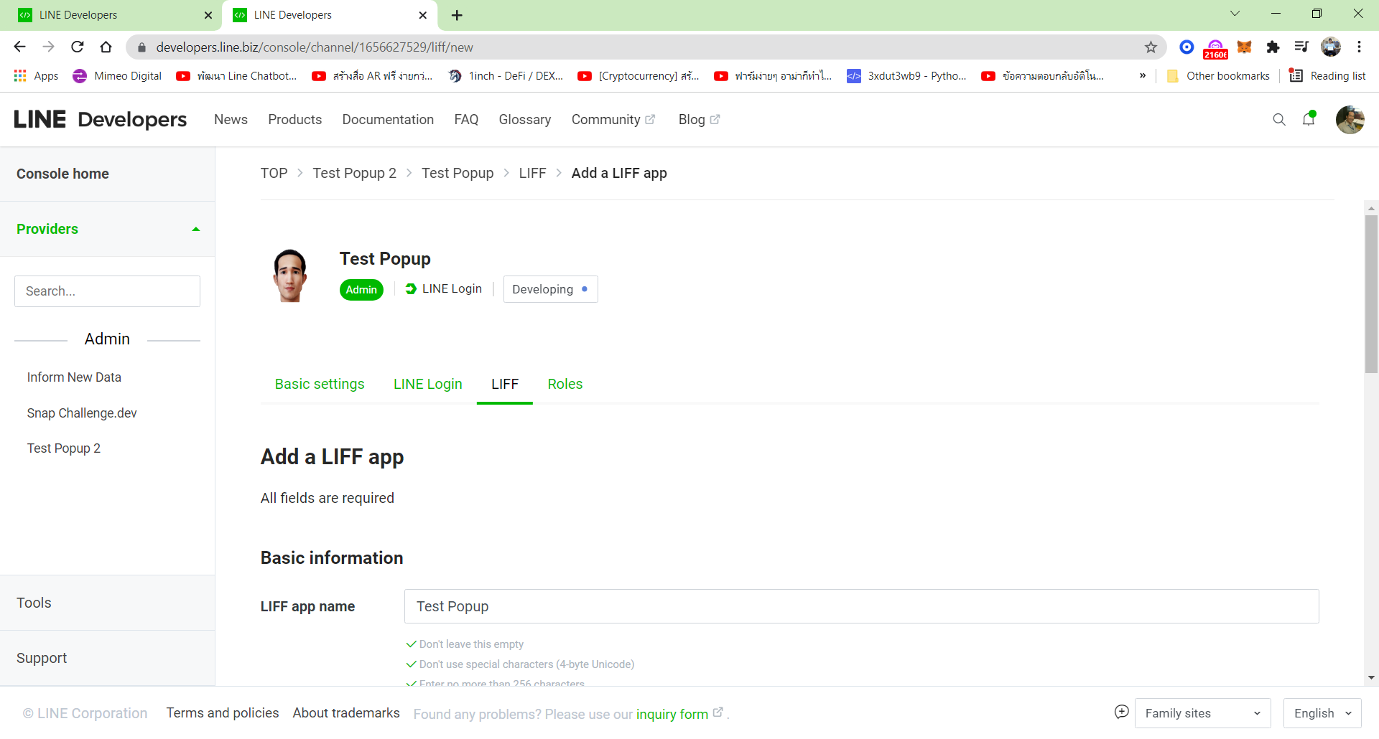

1. New article to success
2. This webpage occurs as same Page21

* Marl 1 Choice: Full = Maximize, Tall = Minimize, Compact = Smaller
* Scroll down

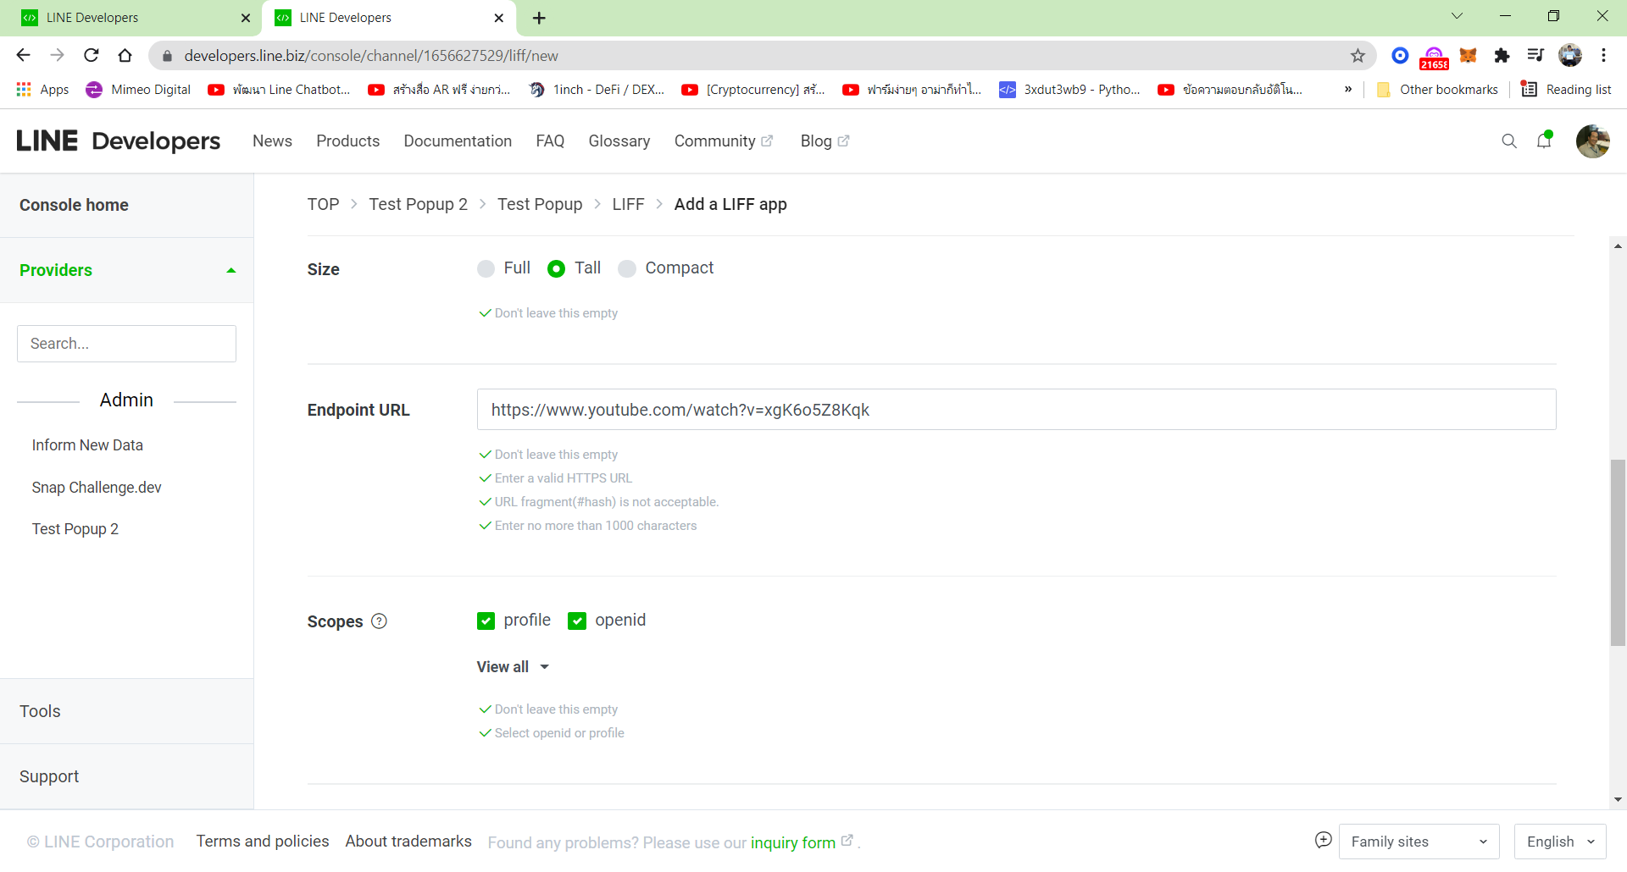

**1.Mark 2 choice**

**1.Mark 1 choice**

1. This webpage as same page 21

* Mark 1 choice

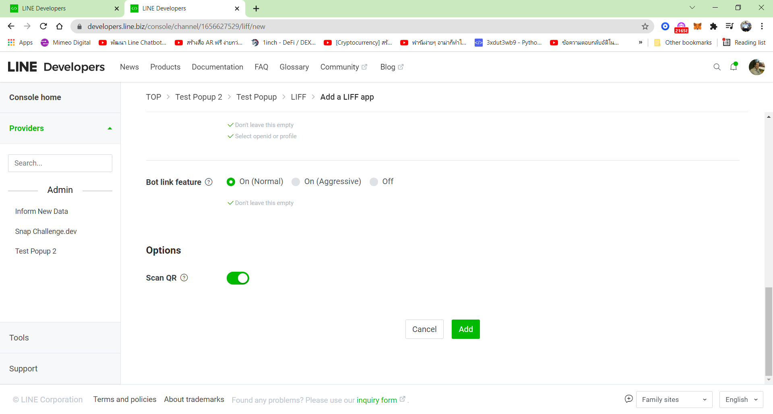

**3. Click Add**

**2.Open to Green**

**1.Mark 1 choice**

1. This webpage occurs to **Add** success

* Scroll down

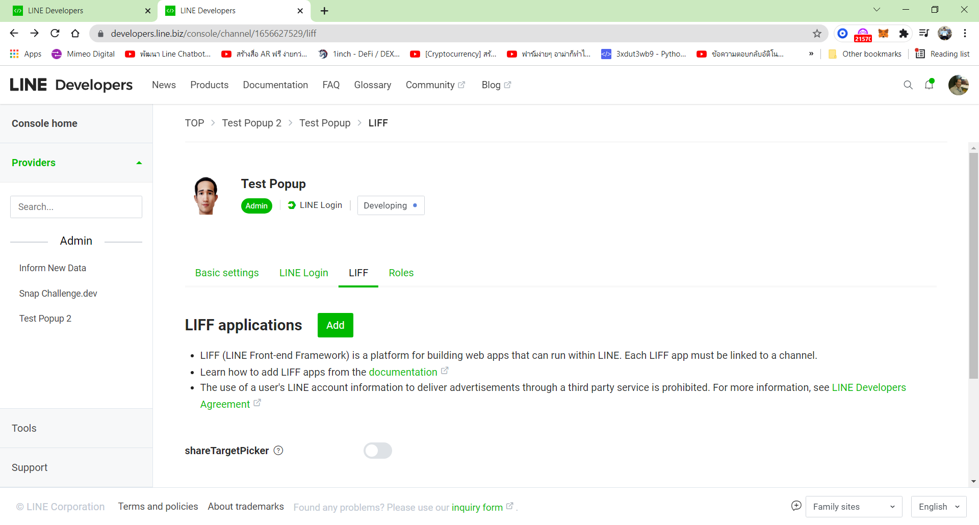

**3.Add occurs to success**

1. This webpage occurs as same Page 24

* **Click** Domain

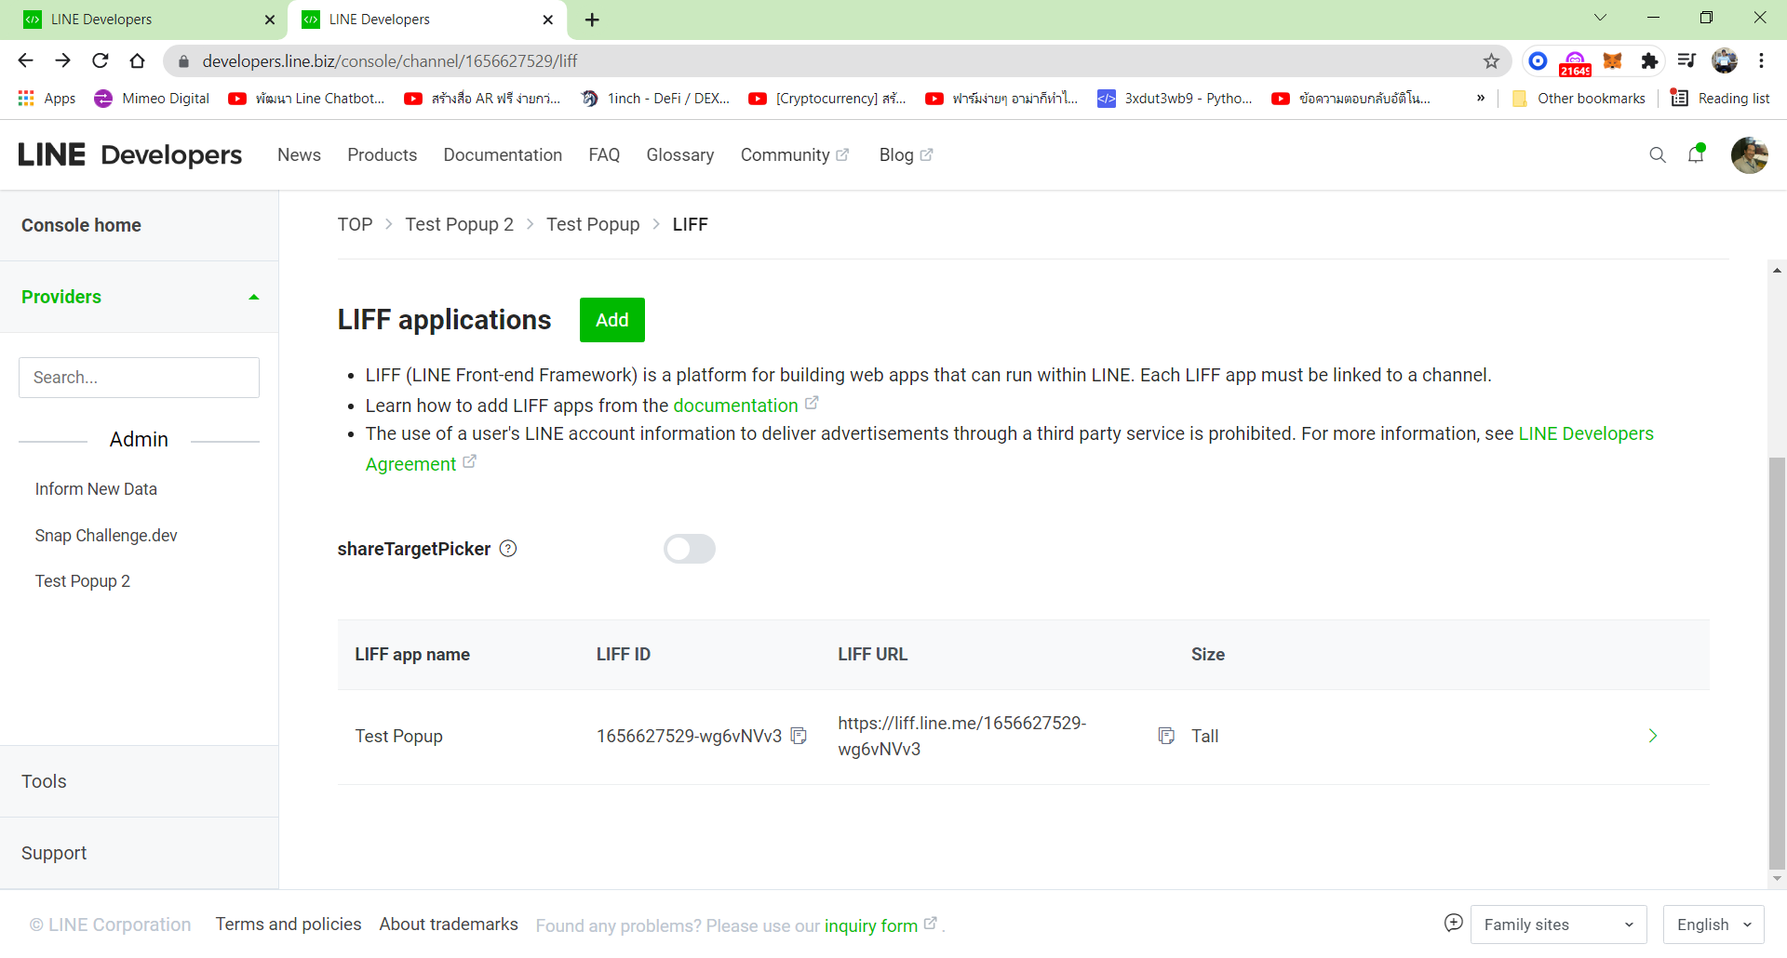

**1.Click this Domain**

1. This webpage occurs in **Finished for setting in Line Developers**

* **Copy** LIFF URL to Line Application, just do it once times.
* **Copy** Domain or Website address from Any website, any time.

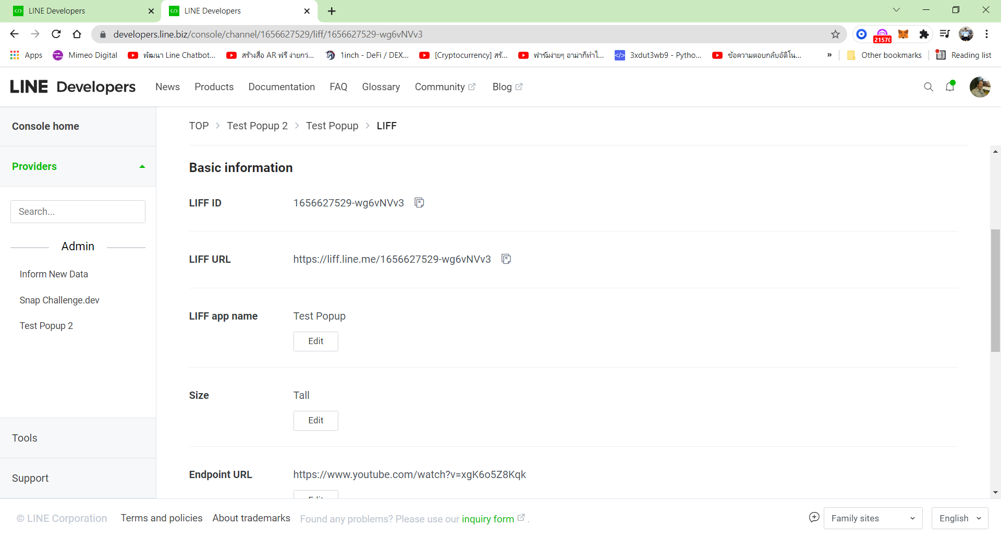

**2.Copy any Website to Endpoint URL**

**1.Copy LIFF URL to LINE Application**

1. This Line Application for group of nodes to copy LIFF URL

* Double click Domain oe Website address to See Theta Token or Theta website.

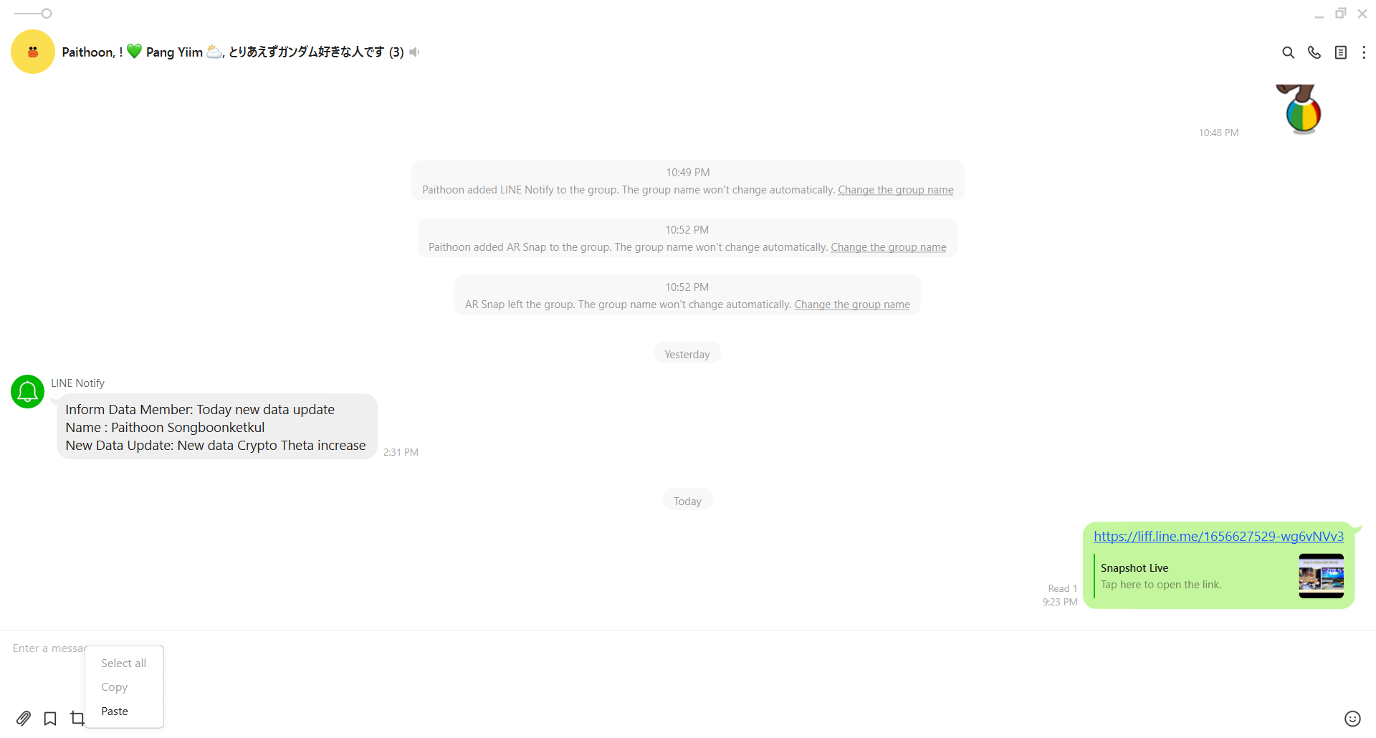

**Double click Domain or Website** Address

1. Theta token or Theta Wetsite occurs after tat Click at Line Application.

* It can use via PC Line application or Smart Phone Line Application

